**Experiment No:**

Aim : To Study Linear Regression In Weka.

Theory:

Linear regression attempts to model the relationship between two variables by fitting a linear equation to observed data. One variable is considered to be an explanatory variable, and the other is considered to be a dependent variable. For example, a modeler might want to relate the weights of individuals to their heights using a linear regression model.  
Before attempting to fit a linear model to observed data, a modeler should first determine whether or not there is a relationship between the variables of interest. This does not necessarily imply that one variable causes the other (for example, higher SAT scores do not cause higher college grades), but that there is some significant association between the two variables. A scatterplot can be a helpful tool in determining the strength of the relationship between two variables. If there appears to be no association between the proposed explanatory and dependent variables (i.e., the scatterplot does not indicate any increasing or decreasing trends), then fitting a linear regression model to the data probably will not provide a useful model. A valuable numerical measure of association between two variables is the correlation coefficient, which is a value between -1 and 1 indicating the strength of the association of the observed data for the two variables.  
  
A linear regression line has an equation of the form Y = a + bX, where X is the explanatory variable and Y is the dependent variable. The slope of the line is b, and a is the intercept (the value of y when x = 0).

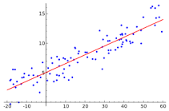

Residuals:

Once a regression model has been fit to a group of data, examination of the residuals (the deviations from the fitted line to the observed values) allows the modeler to investigate the validity of his or her assumption that a linear relationship exists. Plotting the residuals on the y-axis against the explanatory variable on the x-axis reveals any possible non-linear relationship among the variables, or might alert the modeler to investigate lurking variables. In our example, the residual plot amplifies the presence of outliers.

1)Training-Set:The test sets are a percentage of the data that will be used to test whether the model has learned the concept properly (it is independent of the training data).

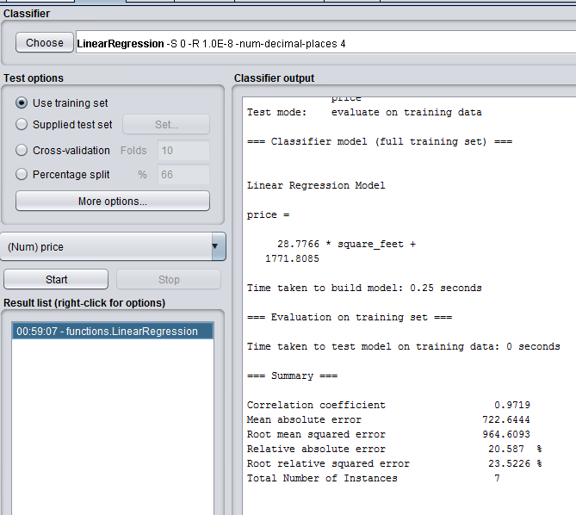

2)Percentage-Split:

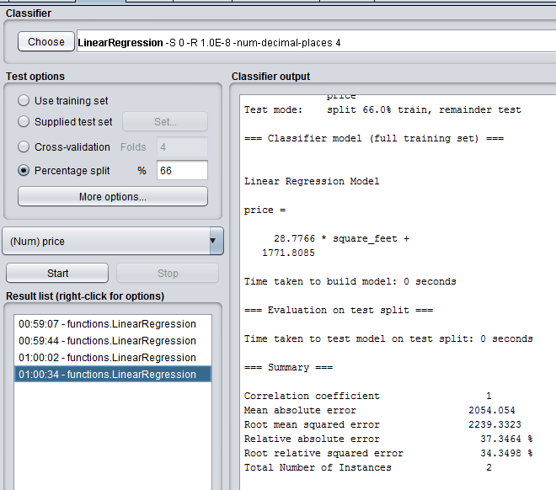

3)Cross-Validation:

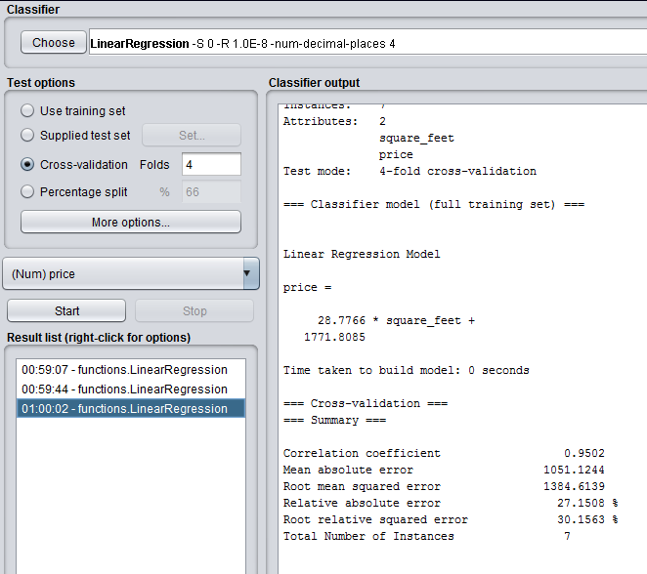

Conclusion:On Given Data Set Cross-Validation Performs Better than Percentage-Split and Training Set With Correlation error of 0.952